Name: ______________________________ Date: ____________
Directions: Please read the passage. Then determine the main idea and three details from the passage.
Animals and Their Environments
A food chain is a link between plants and animals. It starts with a plant. The next part of the link is a plant eater. When the prairie plants were uprooted, the animals that depended on them lost their food source. So while the farmers produced more food for people, they broke the animals’ food chain. For example, if a bird needs seeds to eat and the plant is gone, that bird will not be able to survive. And the animals that ate that bird won’t have any food, either.
A food chain is part of a bigger system called a food web. That web links the living things in an environment. The herbivores in that system depend on the plants. If the plants are removed, the herbivores cannot survive. Herbivores in Chicago include rabbits, squirrels, and many insects. Long ago, they used to include bison and deer. Today you will find some deer in some parts of this area, but you won’t find them in the city.
When herbivores lose their food, they die out. Then the carnivores, the animals that eat other animals, lose their food, too. Wolves used to depend on the deer for their food. Without deer, the wolves lost their food. Foxes died out, too. They had hunted birds, even catching ducks when they were on the side of ponds.
Remove just one kind of plant from an environment and you disrupt a food chain. Plow up the land and you destroy the whole system.
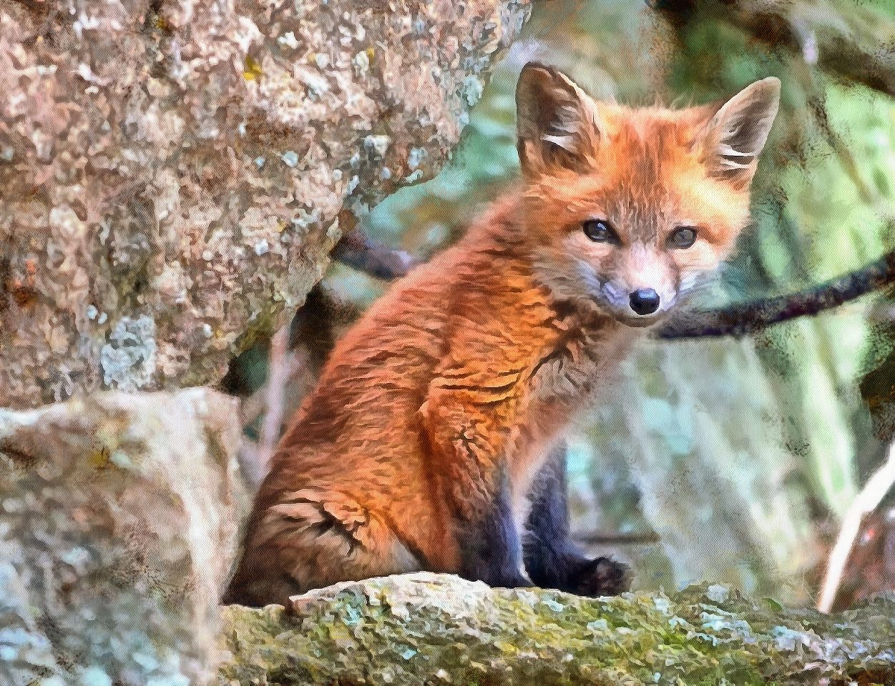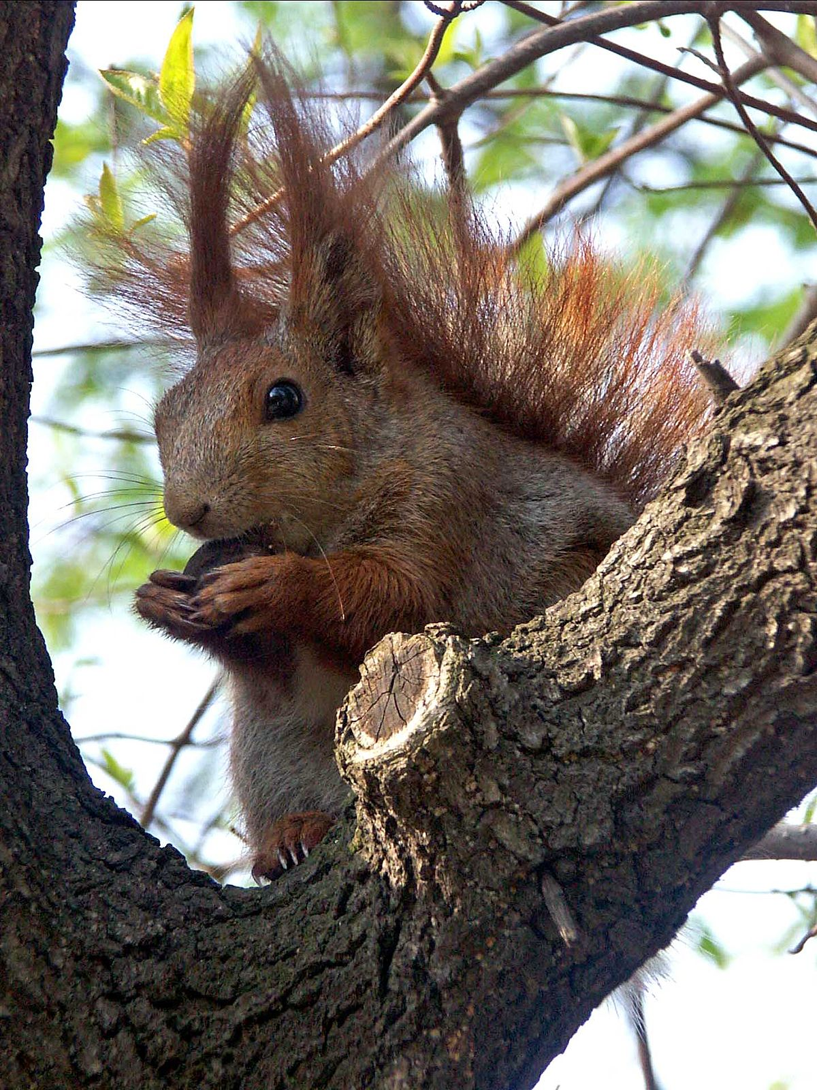
Main Idea:

Key Detail #1:

Key Detail #2:

Key Detail #3:

